**Group - B**

**ASSIGNMENT NUMBER-1**

**1 Aim**

To study the I/O pins in beagleboard.

# Problem Statement

# Write an application to and demonstrate the change in BeagleBoard/ ARM Cortex A5 /Microprocessor /CPU frequency or square wave of programmable frequency.

# Tools used

Operating System:Ubuntu , python, beaglebone black

# Mathematical Model

Let S be the solution perspective of the class frequency

demonstration such that

S={s, e, i, o, f, DD, NDD, success, failure}

s=initial state

e =end state.

i= input of the system.

o=output of the system.

f = function used to manipulate the data.

DD-deterministic data it helps identifying the load store functions or assignment functions.

NDD-Non deterministic data of the system S to be solved.

Success-desired outcome generated.

Failure-Desired outcome not generated or forced exit due to system error.

For class frequency demonstration

s=initial state of the graph ()

s={init()}- creates the graph.

e= graph is changing according to the frequency change of the cpu

Input i=(I1,I2)

I1=blank graph that is created by matplotlib python module.

I2 = axis plotted and labelled.

O= frequency change according to change in frequency of CPU

f=system, xlabel, ylabel, plot, cla, show

Success- desired output is generated and plot is shown.

Failure- desired output is not generated i.e frequency is not changing in the graph.

# State Diagram:

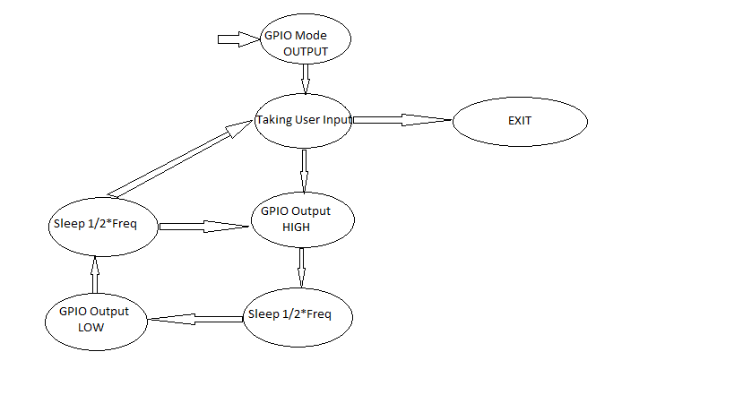

2